

**RUBIX**

*Chat With Ease*

Lakshmi Vyshnavi Perla

Bhargavi Sandhya Podile

Kamal Tej Veerapaneni

Vinay Maturi

**MESSAGE SCHEDULING**

1. Project Goals and Objectives 3
2. Project Plan 4
3. Second Increment Report
   1. Wire Frames 6
   2. Architecture Diagram 9
   3. Class Diagram 10
   4. Sequence Diagram 11
   5. Use Case Diagram 12
   6. Implementation 17
   7. Existing Service 19
   8. User Stories

1. Deployment(Wiki) 20
2. Testing 27
3. Project Management 29

**PROJECT GOALS and OBJECTIVES**

In general, texting of messages takes pace instantly, but to make the messages to be delivered at a certain time or on some condition is called as Message Scheduling. It mainly helps in sending the messages to the recipients at certain time, because sometimes user may forget about that or the user might be busy with his work. This method can also be helpful in sending messages to the recipients based on their input message automatically. Sending the message based on the recipient message automatically will help a lot to the organizations such as colleges and recruitment departments.

**Overall Goal:**

Providing an environment to send a specific message at a certain time and to generate an automated reply for users to queries based on their request subject through mail.

**Specific Features**

* To set time and date for the message to be sent in a chatting environment.
* To setup a mailing system that generates an automated reply to the user based on the user’s message based on the user’s subject mentioned in the mail.

**Significance:**

* To send the desired message at specific time to the recipient. This will elevate the use of message scheduling.
* To increase the efficiency of response to the users through mailing process.

**Specific Objectives:**

* The first and foremost is to increase the immediate responsive naturefor basic questions from an organization.
* To remove the problem of remembering to message every time for each

event.

**Specific Features:**

* A regular chat is included along with the feature of specifying a particular time to send message or for a specific message. In addition to that, a system is created by sending the reply to the e-mails or the messages based on finding the key words of the subject that the user is sending. This can be done by using certain API. So finally using several APIs by adding certain feautures to the existing system would help us achieve the task completed

**Related Works:**

* SMS Sent TIME:

This is an android application which sends messages to the users by setting date and time.

* Text Magic

This is also a kind of website where a message can be sent to the user from its website by giving all the information and by setting the time. This can even send message to other countries also by giving the time of the time zone of that country.

**Implementation:**

This is a part of project, where our idea is implemented in an executive process. This is the phase where, we will give our inputs and follow the procedure to expect the desired outputs.

**Main Modules:**

The web base application requires the following languages.

**HTML (Hyper Text Markup Language) :** This is used to create the display of the pages on the websites that the user interacts with the application.

**CSS (Cascading Style Sheets):** It is used to give the styling for the documentation written using HTML for the web pages.

**JavaScript:** This is a type of programing language used to make the web pages interactive with the user by giving the logic for the items like buttons, links e.t.c,

**Angular JS:** It is a JavaScript based open-source framework which reduces the java script usage effort.

**Boot Strap.** It is a framework used to reduce the work fromt eh scrap and gives an effective view of the web pages and add the functionalities like buttons with easy and good view.

**Existing Services/REST API:**

***Oath Login:***

For this increment the g-mail oAuth login API has been used login into the home page of our website.

***WebStorm:***

To execute the source code, webstorm has been used.

***Chat Environment***

Once the user logs into the account, user can have a chat room where multiple users can chat.

***Mailing System***

The user can have mailing system at which the user can send mail by setting a time to the mail. This environment is created using JavaScript.

***Firebase***

The messages that are being sent in the chatroom will be saved in the firebase database.

**Detail Design of Features**

**Wireframes**

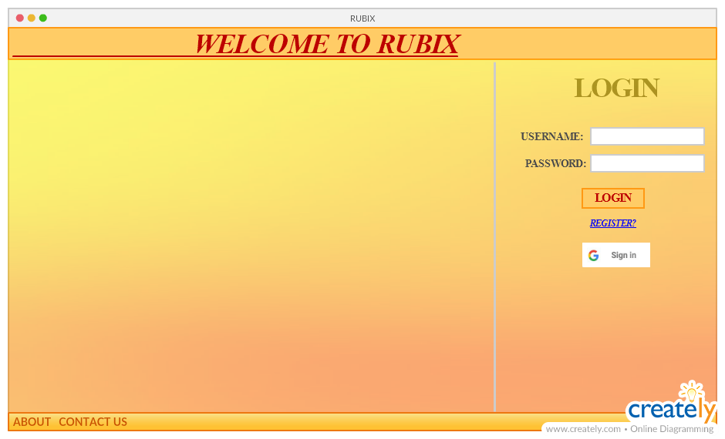

Register Page

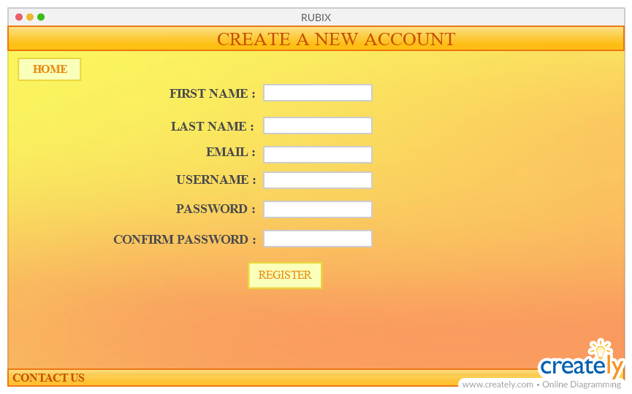

Home Page

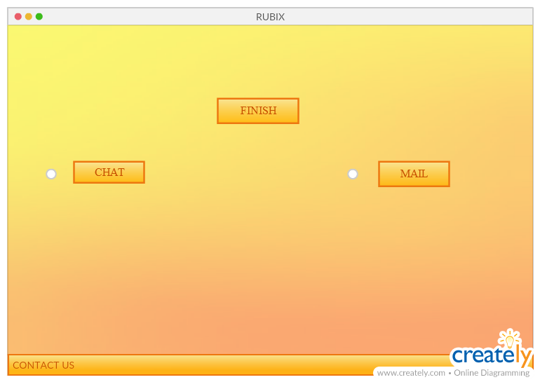

Chat Page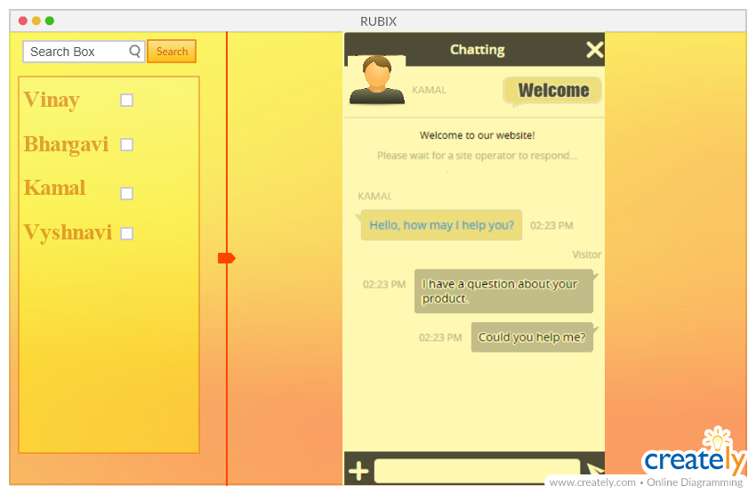

Mailing Page

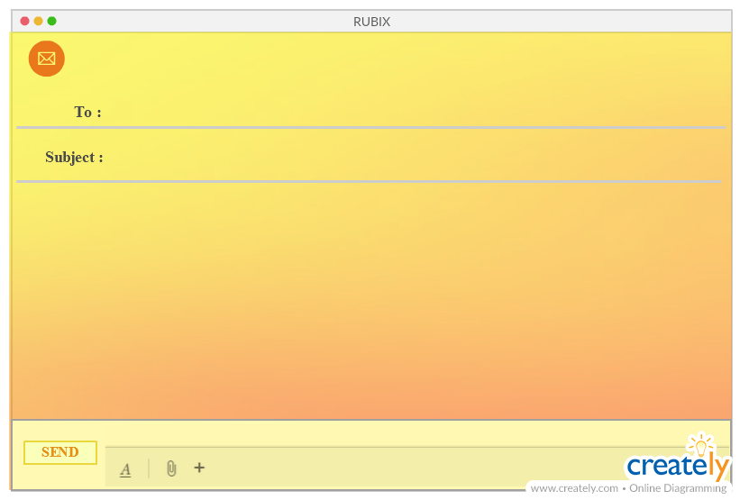

**Architectural Diagram**

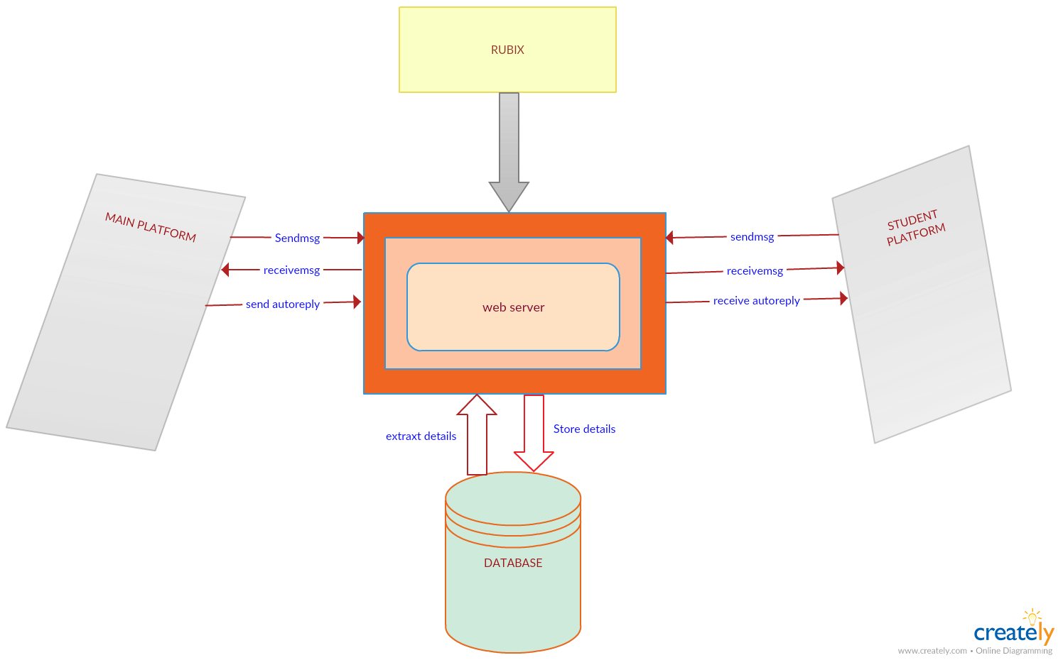

**Class Diagram**

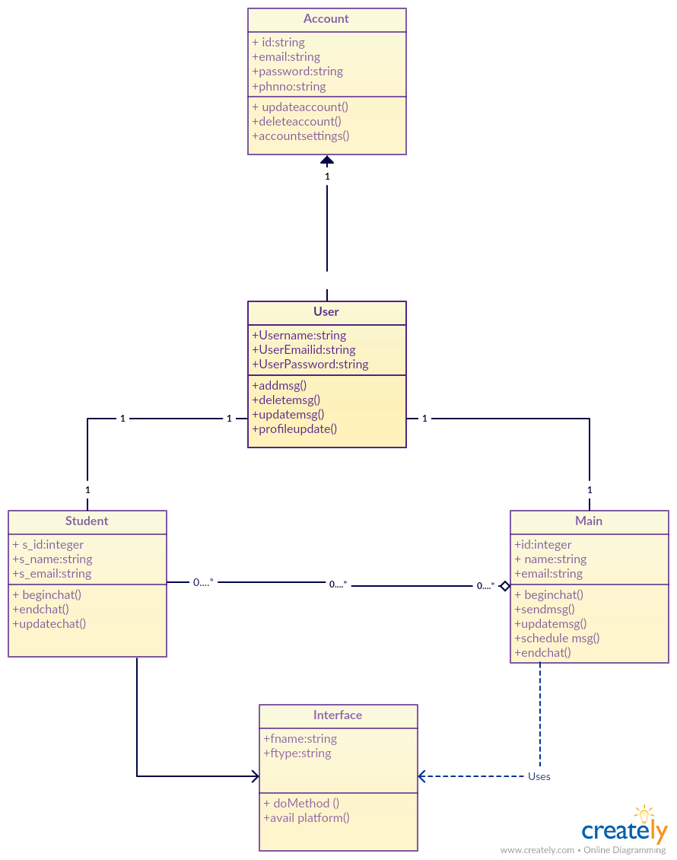

**Sequence Diagram**

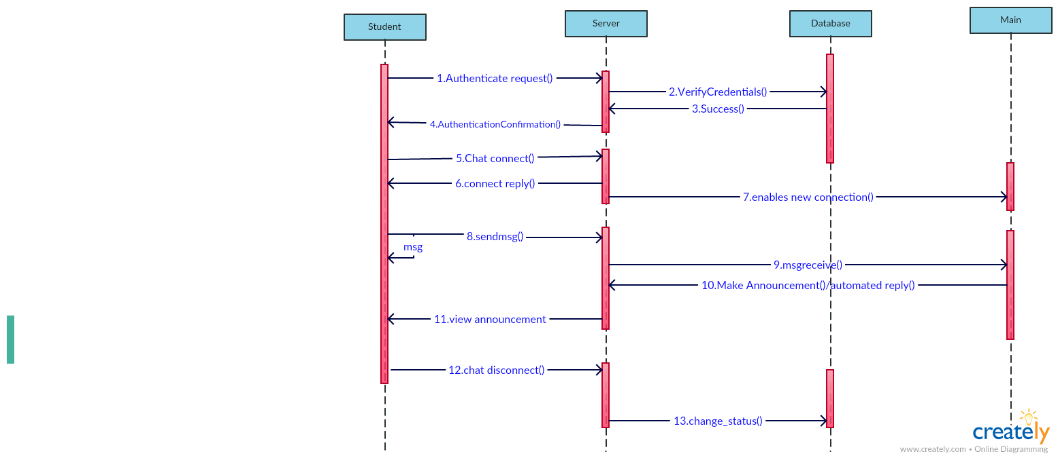

**Use Case Diagram**

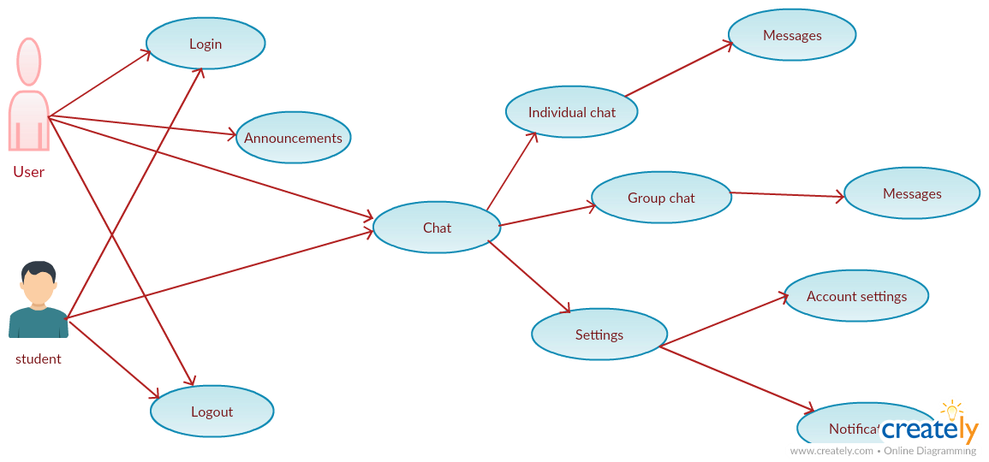

**User Stories**

1. As a user, I want to Login, so that I can ask queries
2. As Main, I want to Login and check the notifications about the doubts from students.
3. As a user, I want to chat with main to ask doubts, so that I can get my problem rectified.
4. As a main, I want to view incoming chat messages, so that I can respond to student’s queries.
5. As a main, I want to post important announcements with a scheduled time, so that I can let students know about it.
6. As a Student, I want to view announcements, so that I can follow main’s announcements.
7. As a main, I can send automated replies to students.
8. As a main, I want to search for a specific Student, so that I can ask or clarify the doubts

**DEPLOYMENT**

The implementation of the website works as follows.

The **HOME** page of our website is

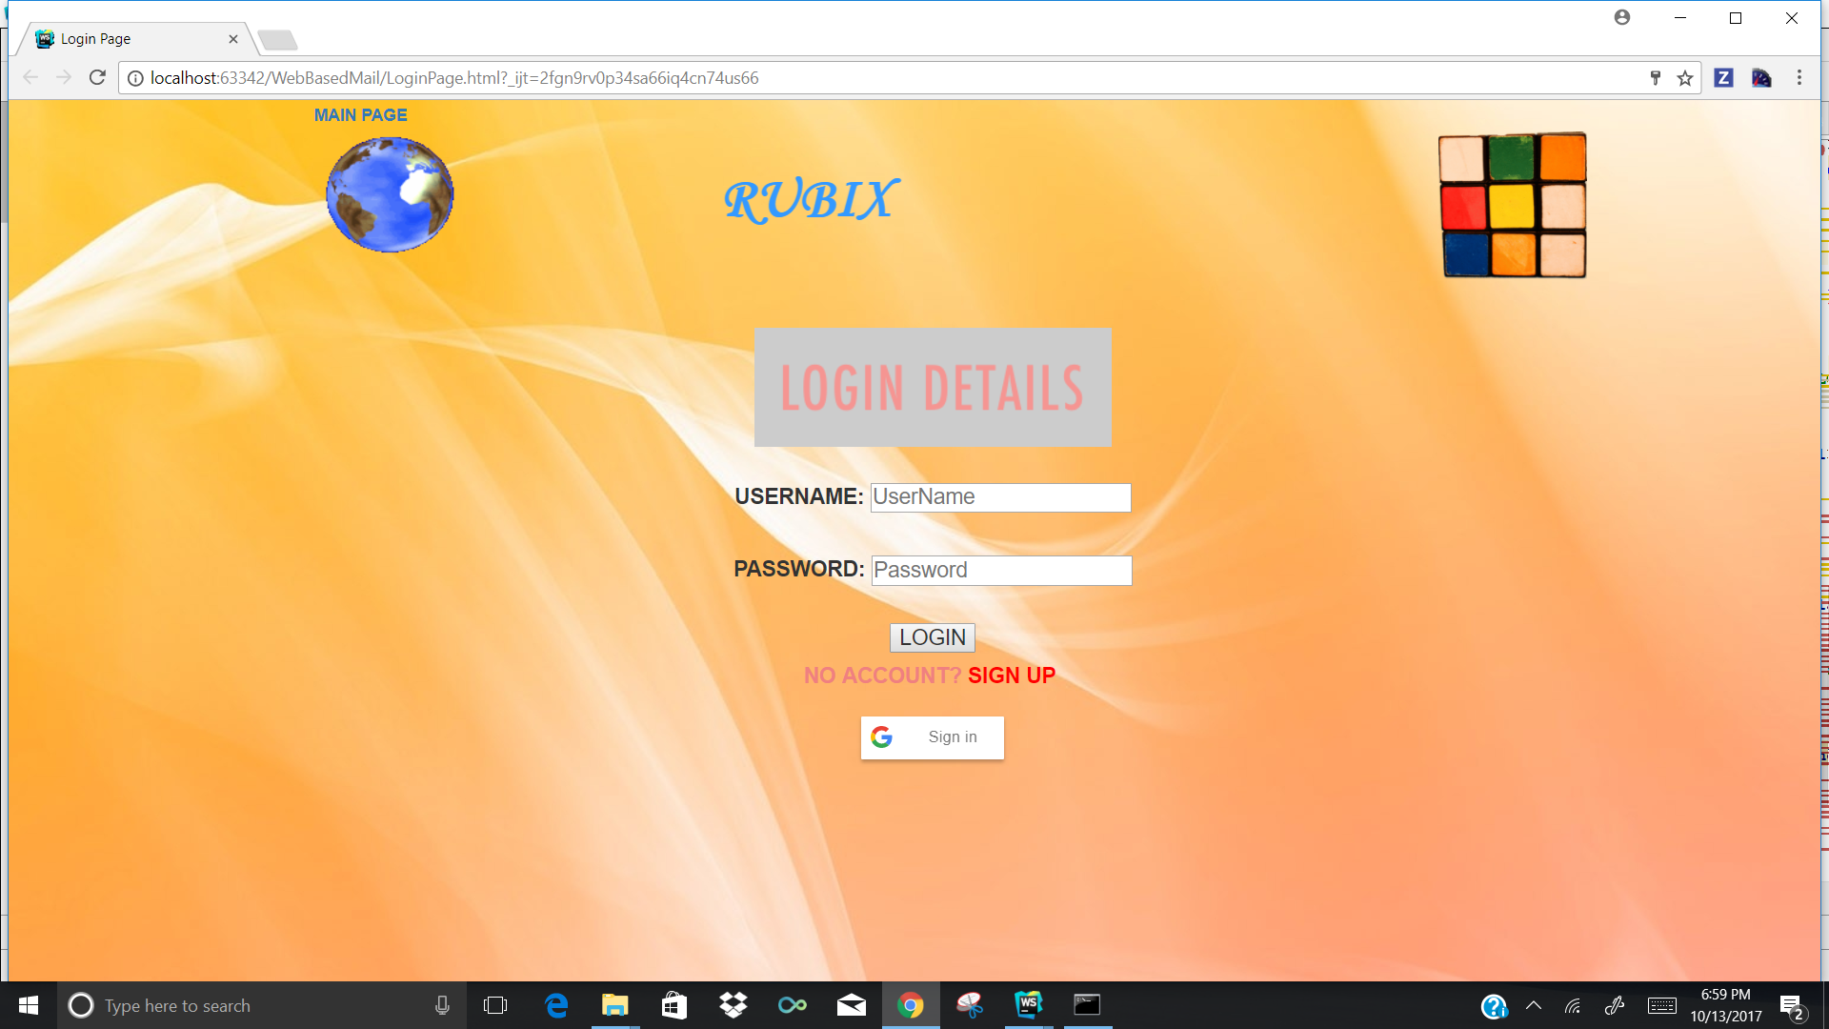

If the user is a new user, the **Registration** **page** can be obtained. The registration page looks as below.

.

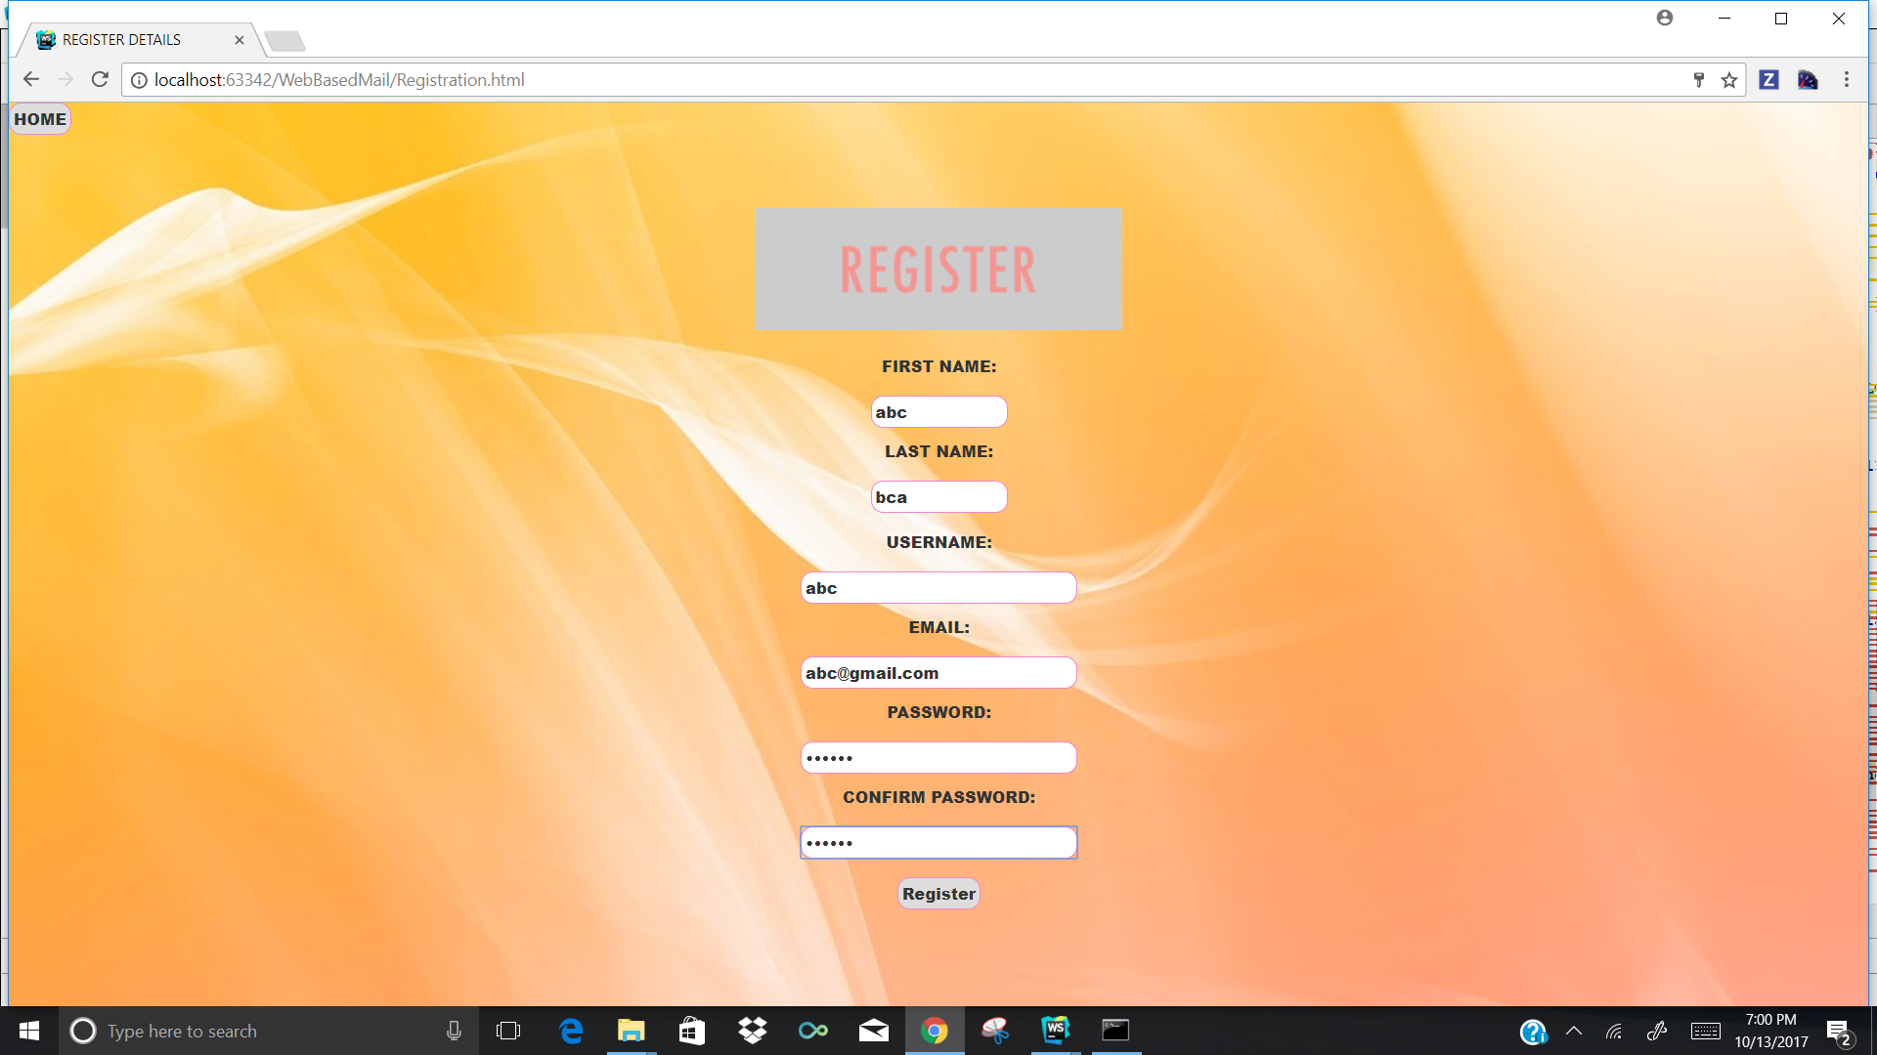

If the user logs in using G-mail Oath login the page looks as follows.

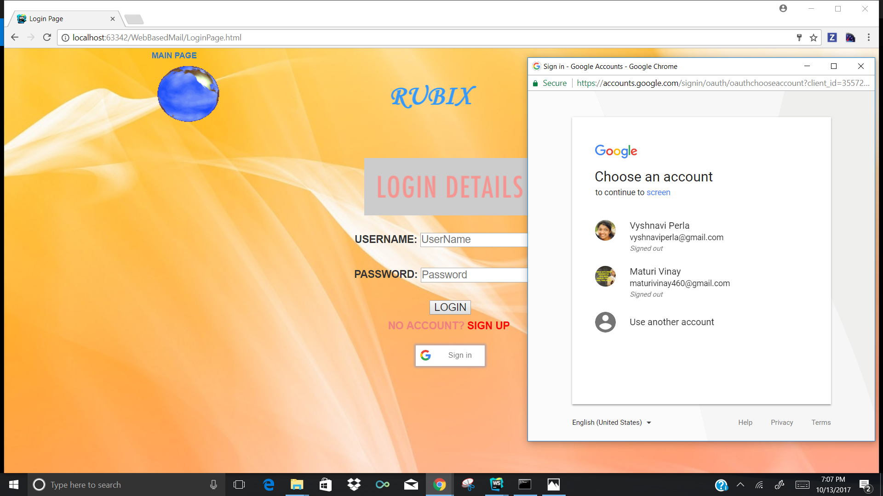

If the user log in using the credentials it looks as follows.

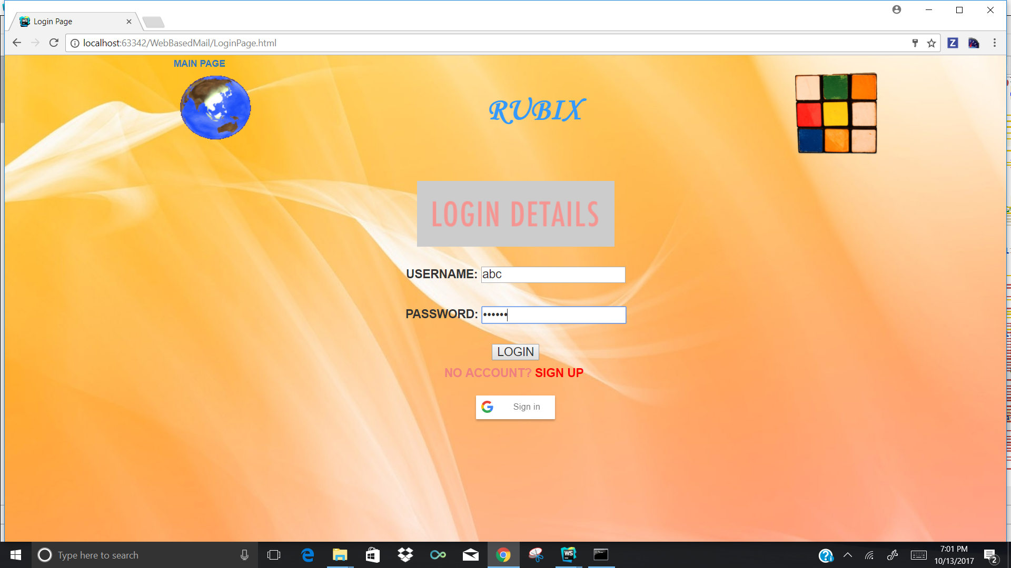

Once the user log in either using his credentials or using the g-mail oath login, the home page will be opened. It looks as follows.

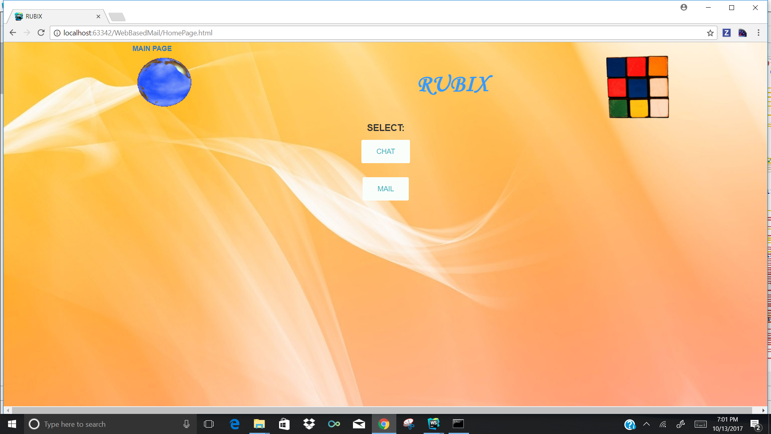

***Chat Room***

Once the user clicks the CHAT button, a chat room opens where the user can chat with multiple users.

The chat room looks as below.

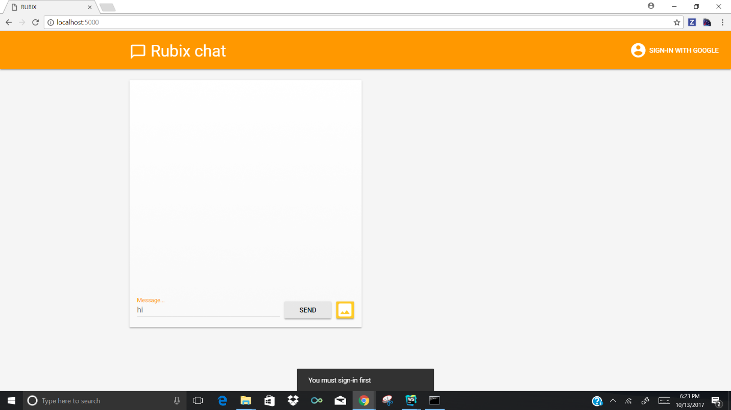

The users whoever want to join the chat room has to sign in using their G-mail login,It looks as follows.

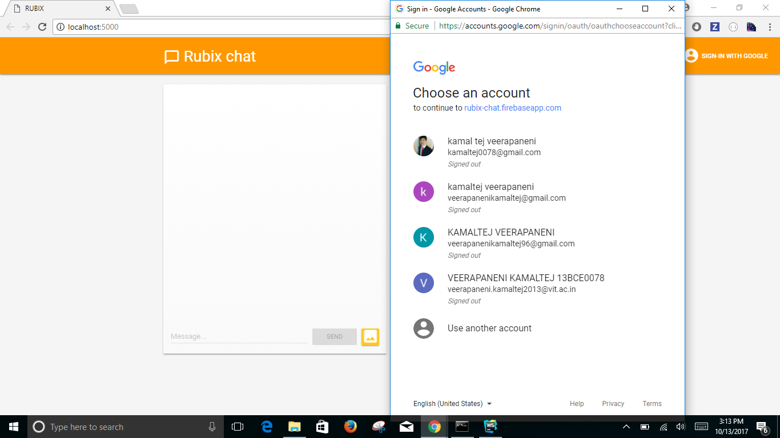

The messages that are sent by the users will look as follows.

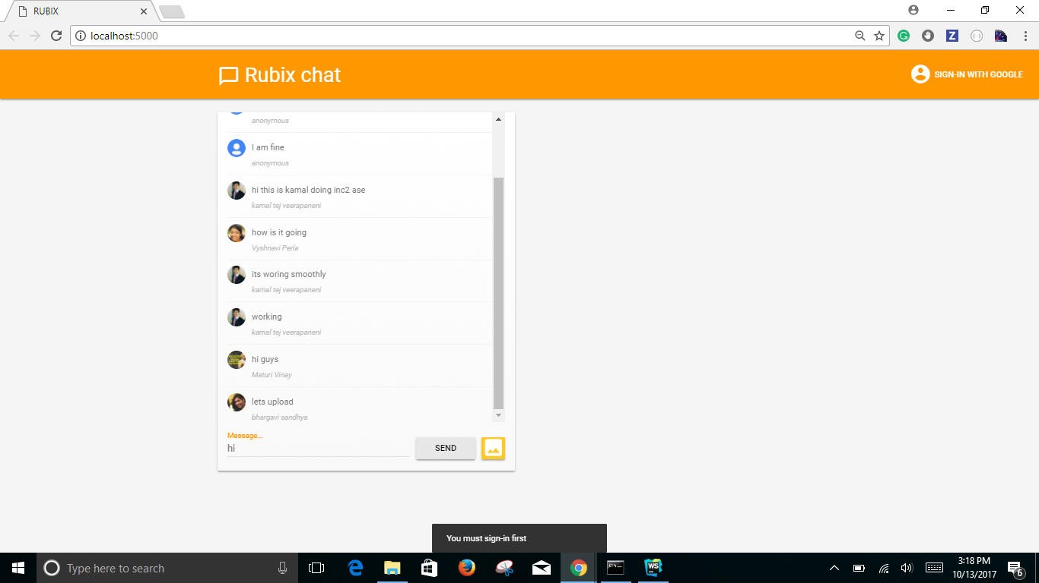

The user can send images in the chatroom, using the option and looks as below

The messages in the chat room looks as follows.

***Mailing System***

If the user selects the mailing system, the following page opens where user can send a mail to the desired persons mail.

The mailing home page looks as follows.

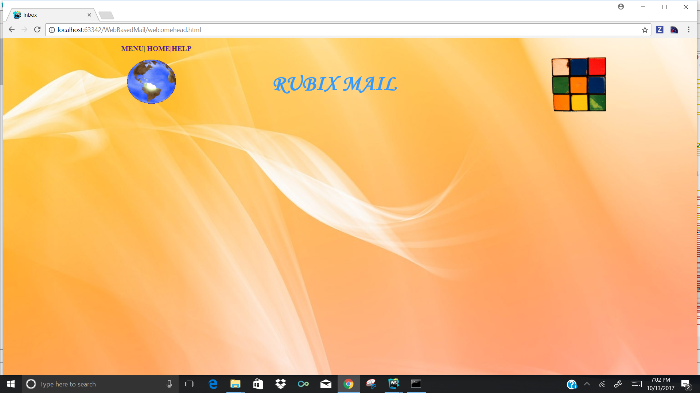

The mailing system of the page looks as follows with scheduling option.

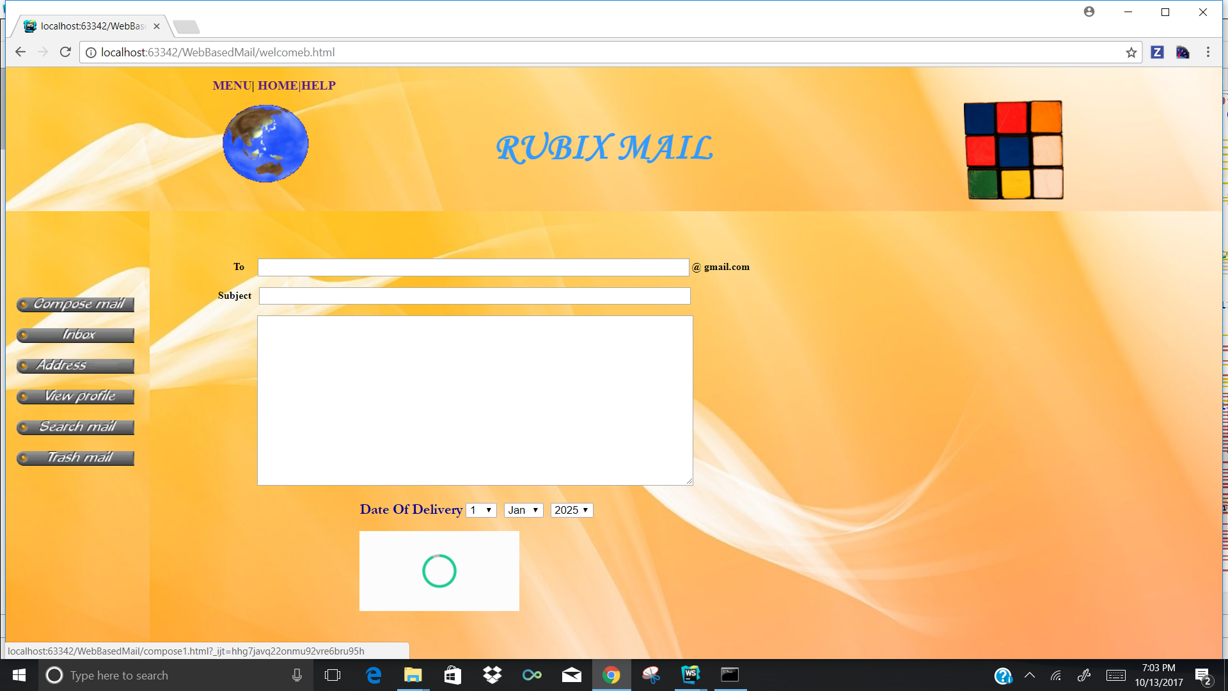

***Firebase page***

The firebase login for the application looks as follows.

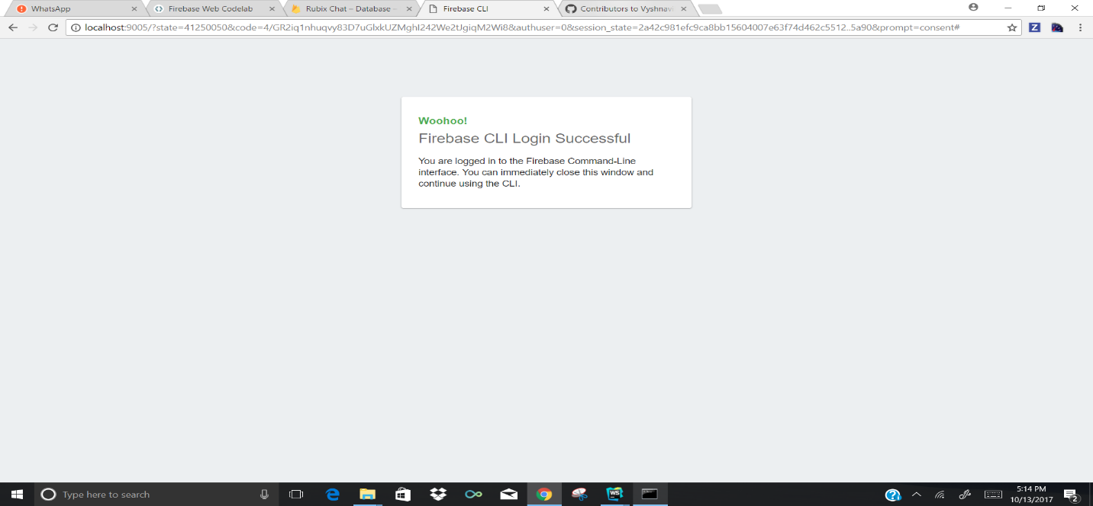

The data will be stored into the firebase and looks as follows.

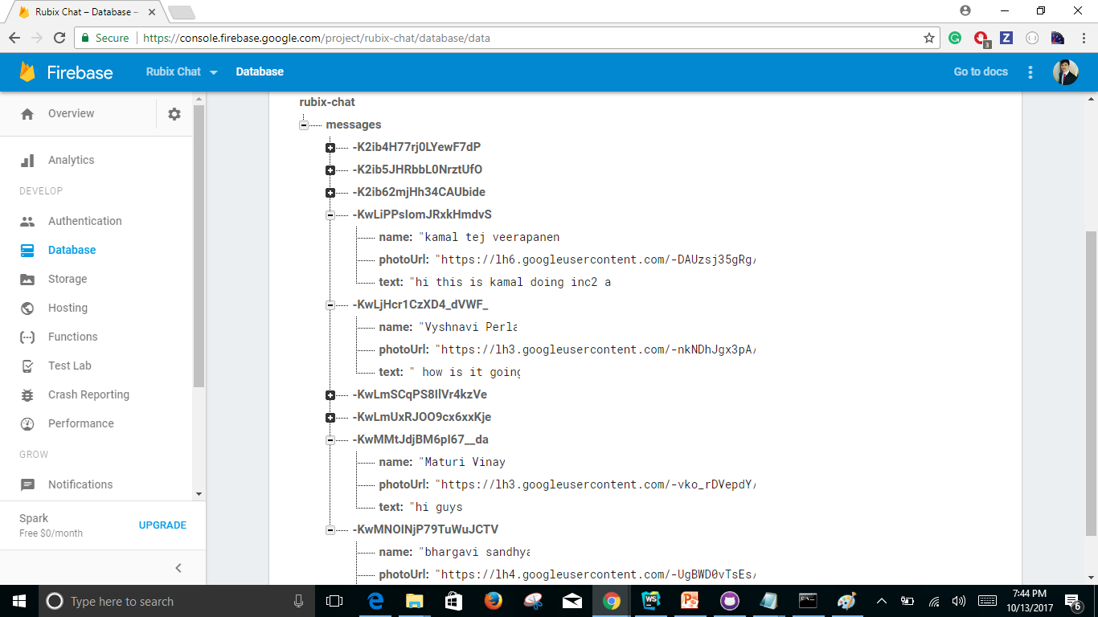

**PROJECT PLAN:**

**Burndown Charts of the issues are as follows.**

Burndown Chart for firebase platform

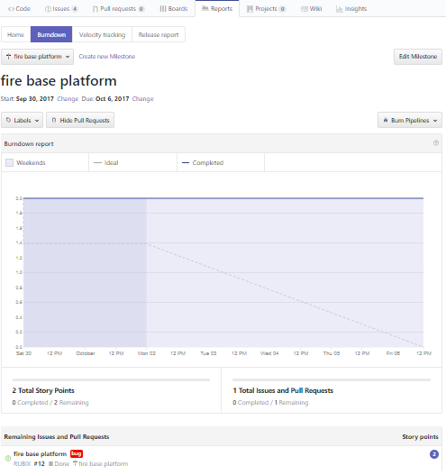

**Burndown chart for designing of increment**

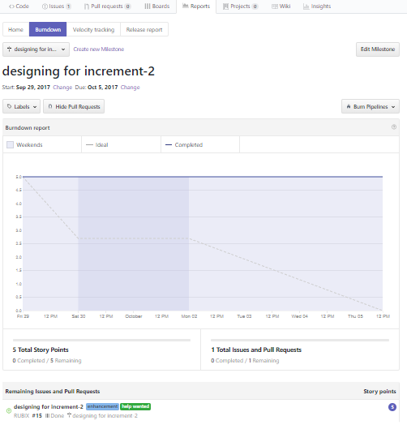

**Burndown chart for testing**

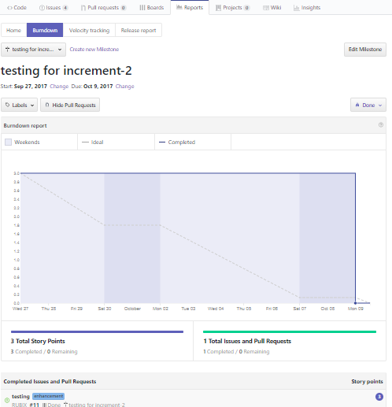

Burndown chart for chat application

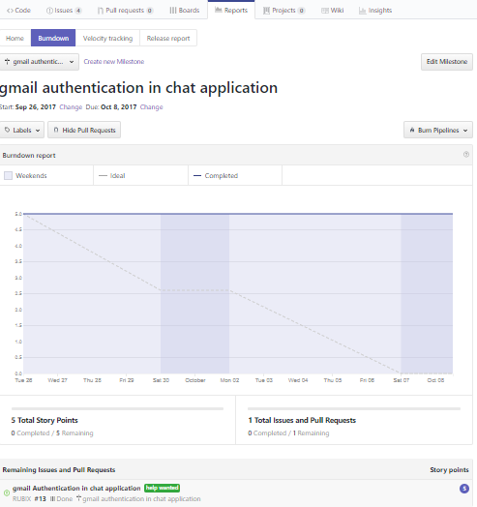

**YSlow Code quality of the pages are as follows.**

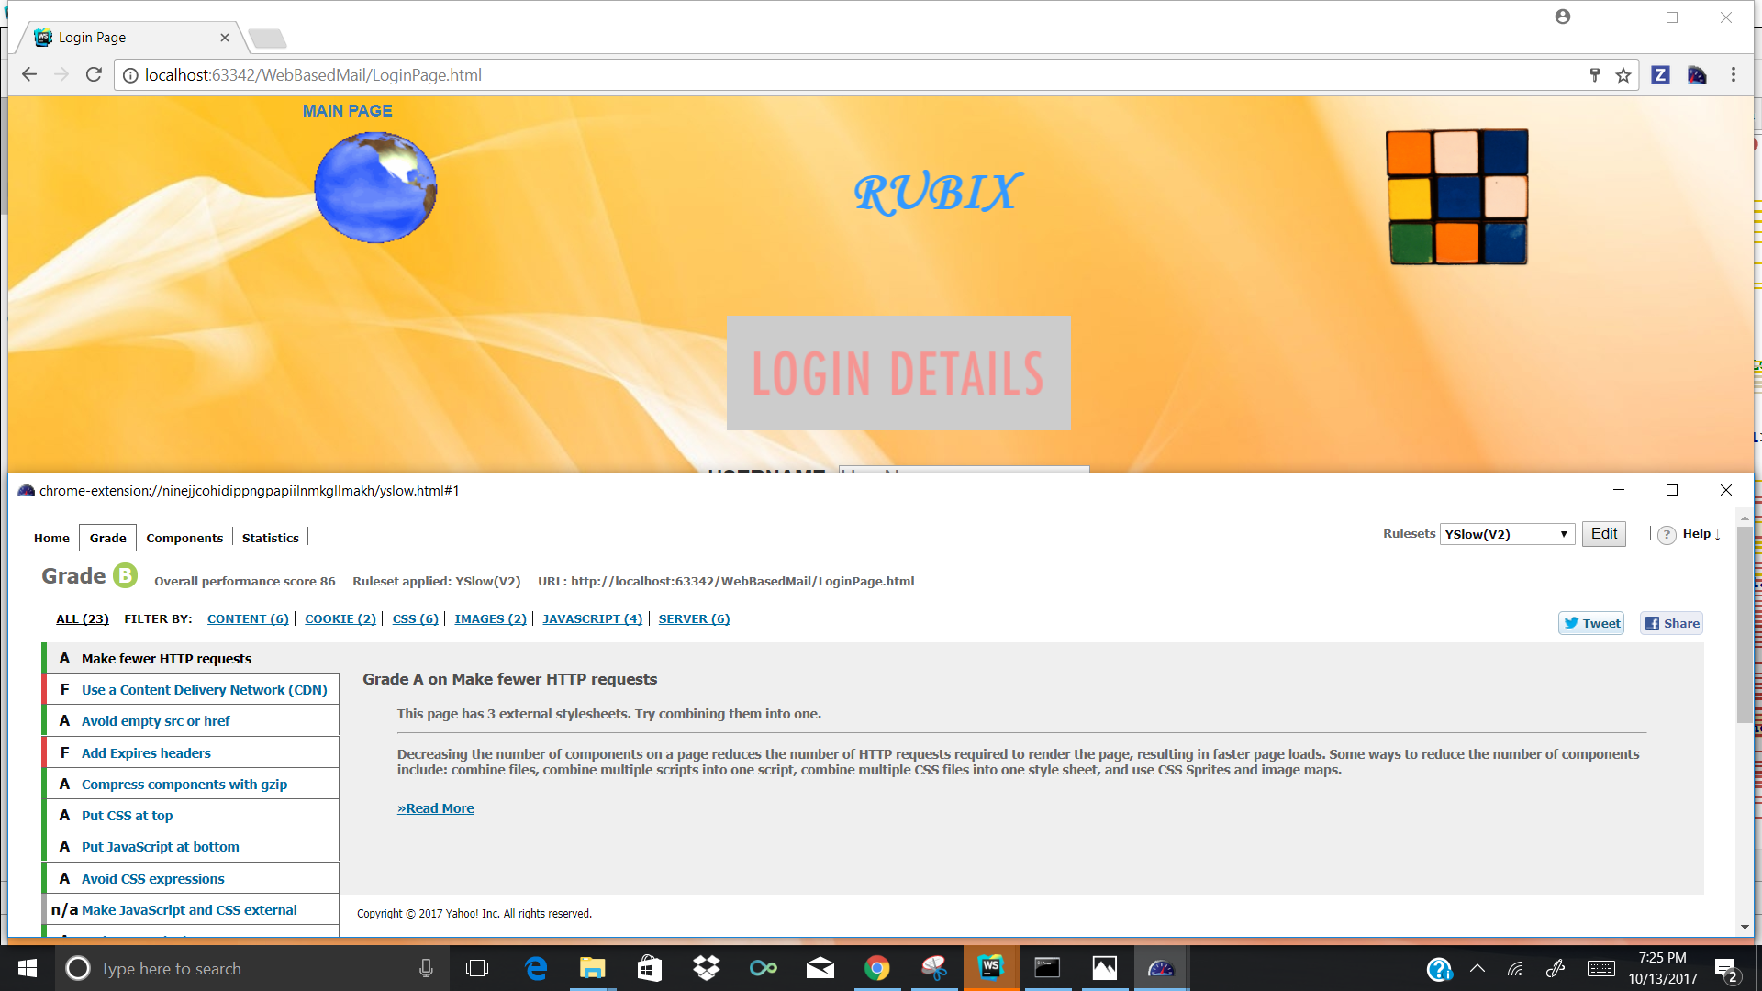

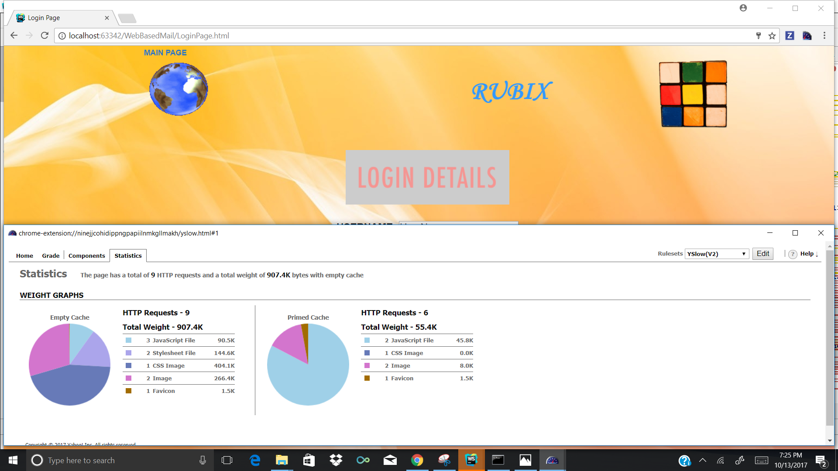

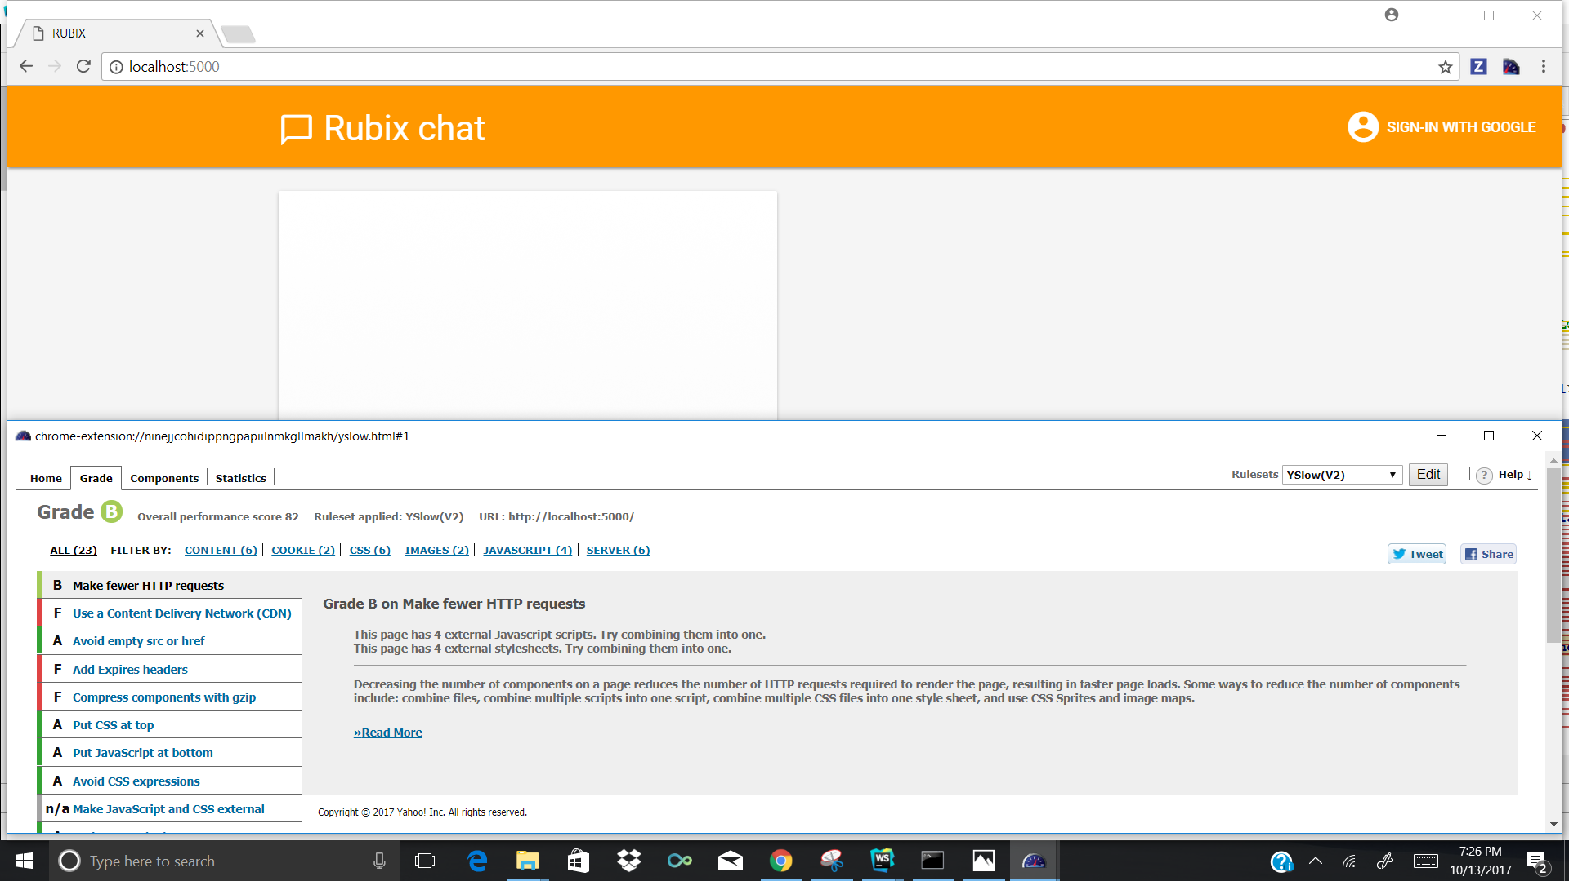

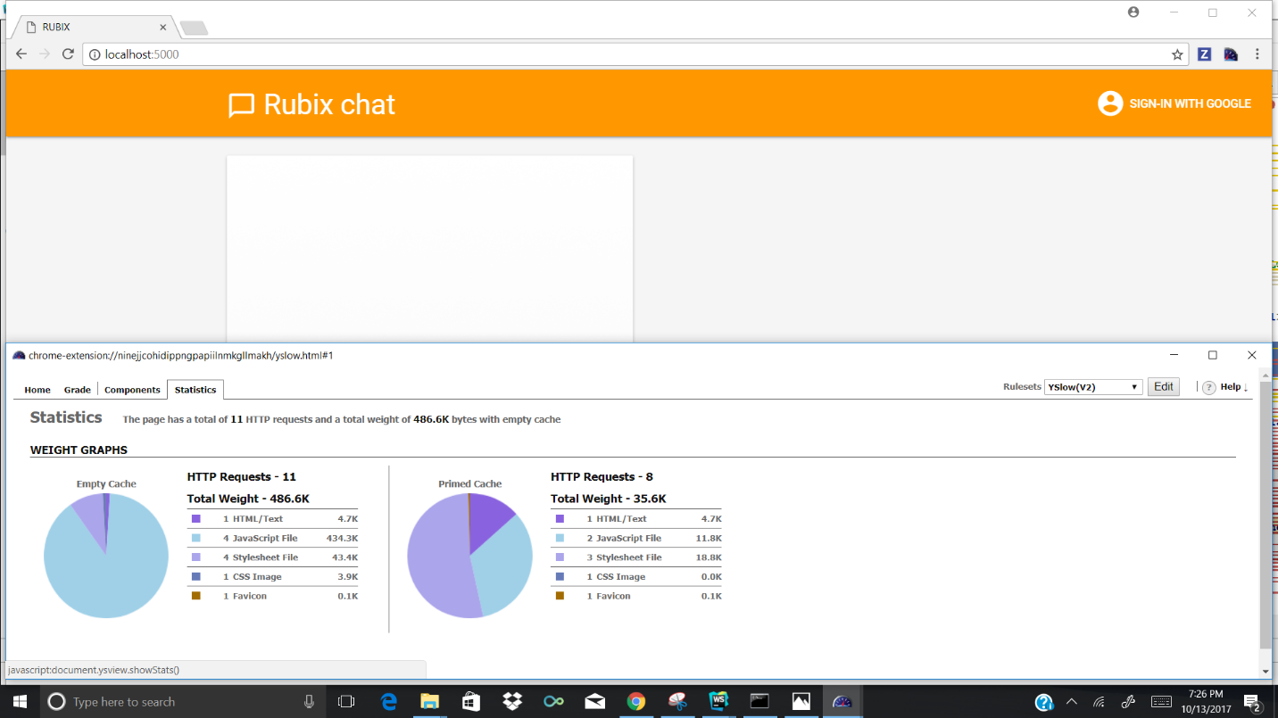

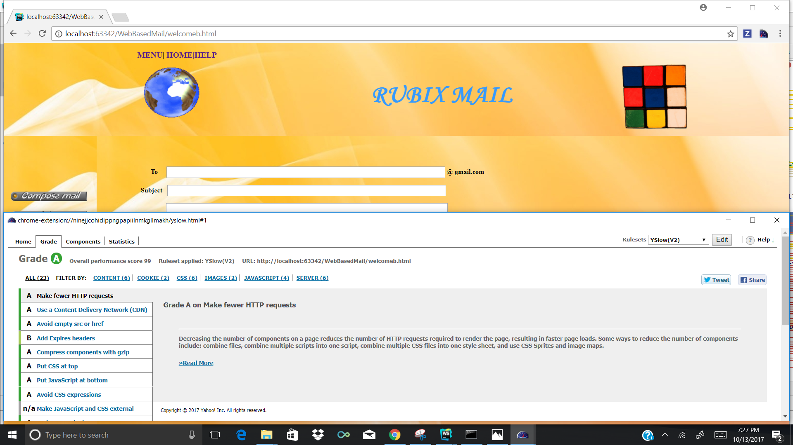

**Testing**

1. Unit Testing

This testing is performed by the Developers in stages to test the design of the application. The small components of the code are tested individually to check if they are working correctly. Unit testing involves testing of the functionalities which are most crucial for that unit or component. This helps the developers to rectify the code at the same instance of the testing is performed. The testing will be limited to the specific components only and rectifying or correcting the code of that unit will not hamper the functionality of other components of the application. Once all the units are identified and tested separately. White Box Testing is used for executing a Unit Test. Debugging the code in this stage is helpful and advantageous. Once the all units/components of the application are working efficiently, error free and per expected results, these can be integrated with larger components and Integration Testing can be done.

|  |  |  |  |
| --- | --- | --- | --- |
| **Case** | **Test case Description** | **Expected Result** | **Actual Result** |
| Login | Enter invalid username and password | Error message should pop up saying invalid credentials. | PASS |
| Login | Enter valid username and password | Page should redirect to Home page | PASS |
| Signup | Mail id and wrong password | Gives error message | PASS |
| Signup | Password and confirm password should match | If this succeeds it redirects to login page | PASS |
| Chat Button | Entering the Chat environment | Chat Room for the users | PASS |
| Chat Message | Enter Message only after signing in through Gmail | Shows small popup at bottom if not signed in | PASS |
| Send Message | The message will be sent | Send message in the chat room | PASS |
| Email Environment | Mailing system | Mailing environment will be opened. | PASS |

**Project Management**

Implementation Status Report:

Work completed and Contributors:

1. **Firebase Platform** : Kamal Tej Veerapaneni , Lakshmi Vyshnavi Perla, Bhargavi Sandhya Podile , Vinay Maturi
2. **Testing** -Bhargavi Sandhya Podile,Kamal Tej Veerapaneni,Maturi Vinay,Lakshmi Vyshnavi Perla
3. **Designing**-Lakshmi Vyshnavi Perla,Bhargavi Sandhya Podile,Vinay Maturi,Kamal Tej Veerapaneni
4. **G-mail OAuth**  :Vinay Maturi,Lakshmi Vyshnavi Perla,Kamal Tej Veerapaneni,Bhargavi Sandhya Podile

**BIBLIOGRAPHY**

1.www.wikipedia.org

2.www.firebase.com

3.devolopers.google.com